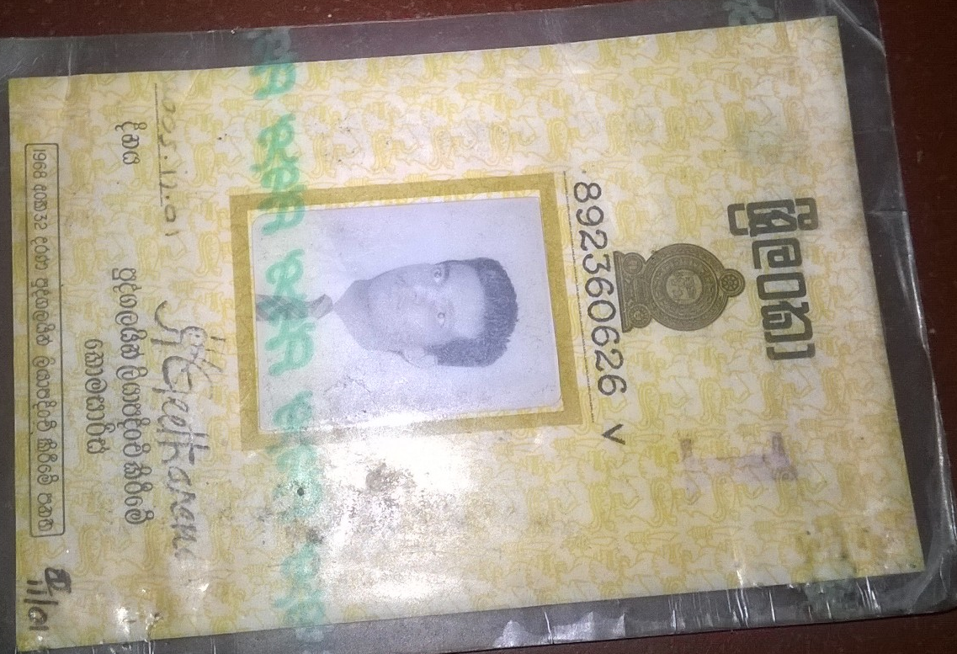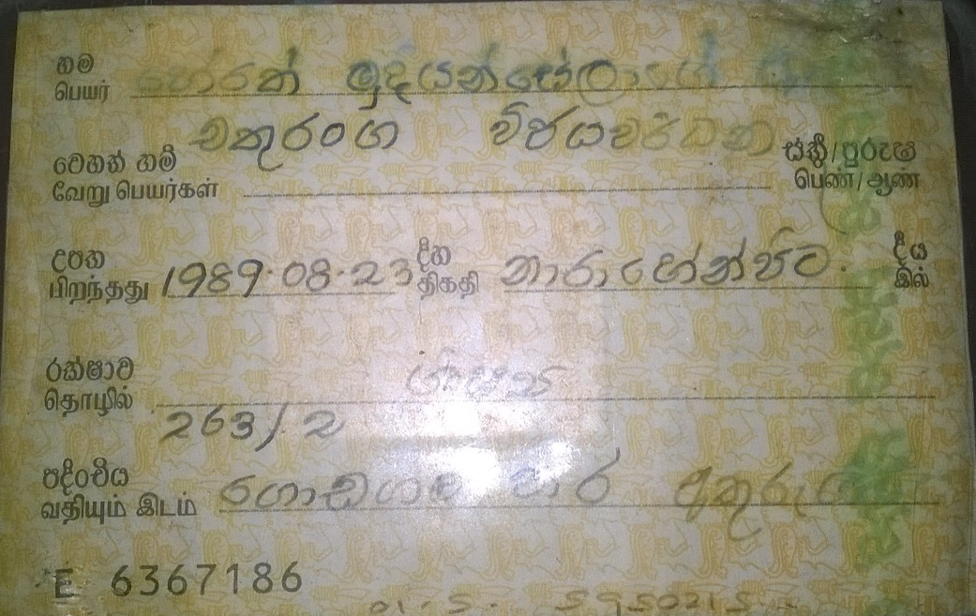

Name: Herath Mudiyanselage Asiri Chathuranga Wijeywardana.

Id no: 892360626v

Address: 263/2, Godagama road, Athurugiriya.

Contact No: 071-5995257

Package : 9Gb Data